ALB Ingress SSL Discovery:-
ALB Ingress SSL Discovery Host:-
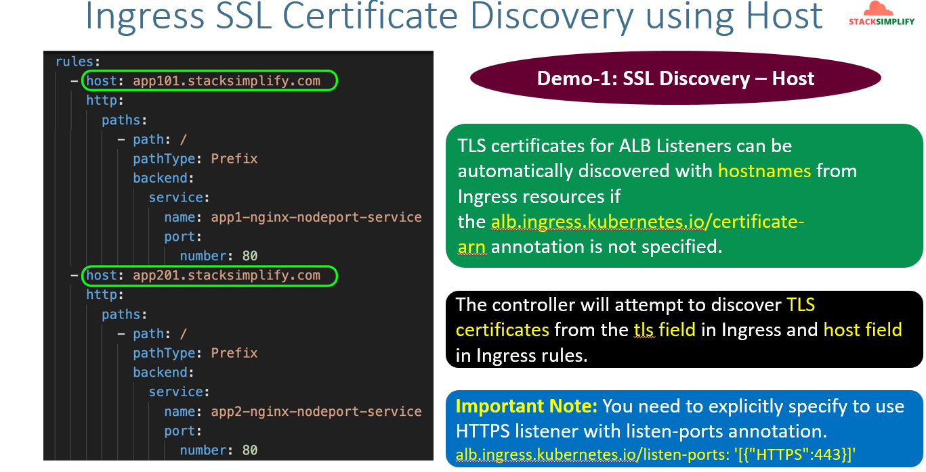
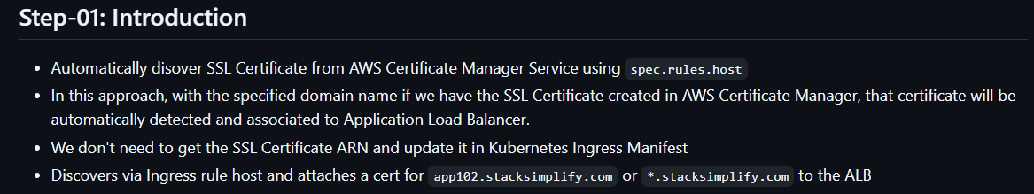
It’s not required to define the annotation for ssl certification. It will automatically detect the ssl certificate like if you define the ssl certs like *.maitesworld.com.
ALB Ingress SSL Discovery TLS:-
Other than host based routing if you use path based you can use TLS.
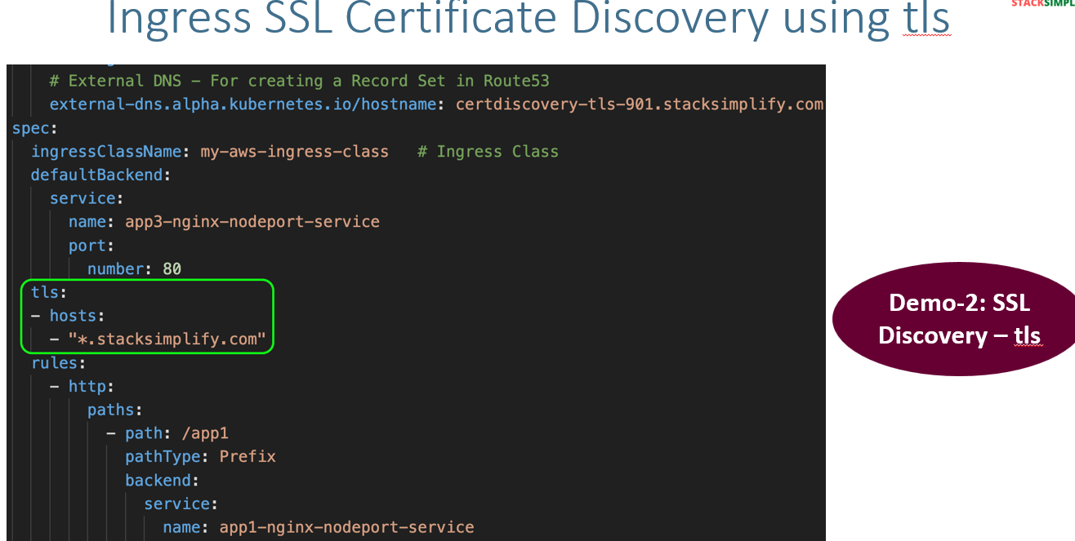
Here we will define our hosts under tls like ‘*.stacksimplify.com’ automatically it will associate with Ingress.
Note:- Whenever we use SSL Discovery Host and TLS it’s not required to define the SSL certificate annotation.
Implement SSL Discovery using Host:-
I have commented the ssl cert ARN line.
After applying check for external DNS log pods.
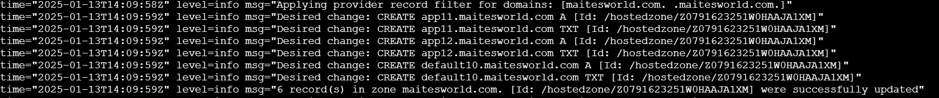
You can also verify in loadbalancer listener tab.
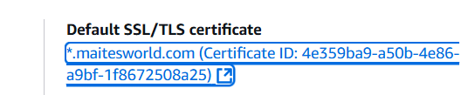
Implementation of ALB Ingress SSL Discovery TLS:-
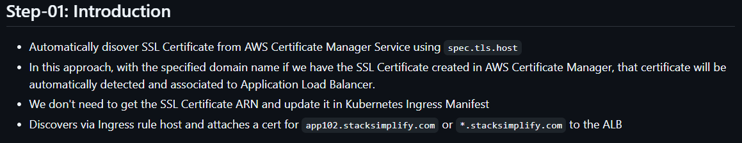
All the previous session manifests we will copy. Now, we are going to make changes like below for ingress.
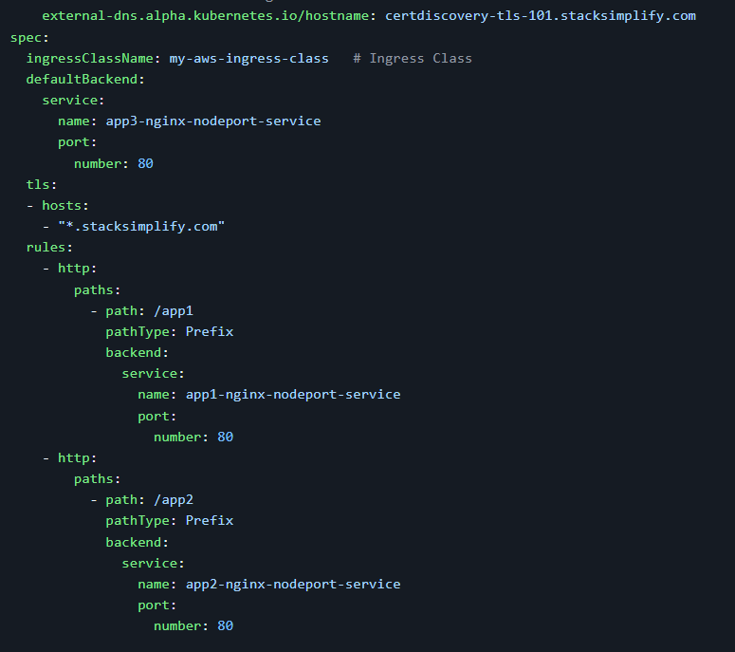
Run apply command and go to listeners in LB verify the certs got associated or not.
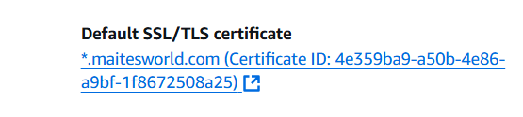
In Route53 Hosted zones you can see this.
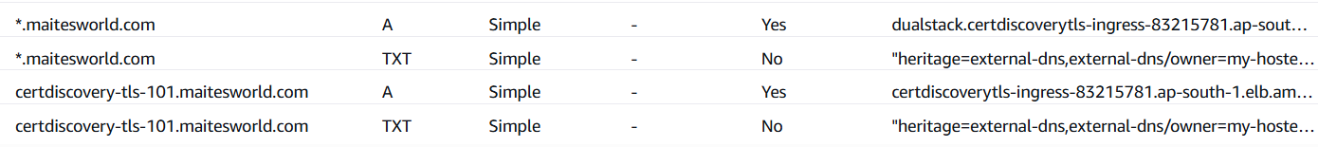
And if you try access in browser you can access it

